Guidance for Virtual Classes at Volunteer State Community College
(Adapted from Guidance for Recording Class Sessions with TechConnect (Confer) Zoom by Michelle Pacansky-Brock and CVC-OEI, licensed under Creative Commons Attribution 4.0.)
Created: August 20, 2020; last updated January 12, 2021
Developed in collaboration amongst Vol State:
- Faculty
- Academic Support
- Information Technology
This document provides recommended practices for holding and recording virtual (i.e., synchronous or live) class sessions. Appendix 1 includes a student consent form you may wish to use.
Instructors sometimes record virtual class sessions so that students can watch a missed class session or review an earlier session, or for the instructor to share with a future class. Depending on who is identifiable in the recording, the recordings may constitute educational records that are protected under the Family Educational Rights and Privacy Act (FERPA) — the federal student privacy law.
Additional information about photos, video, and audio recording under FERPA can be found in the US Department of Education FAQs on Photos and Videos under FERPA.
If you have questions about how FERPA relates to your specific situation at Volunteer State Community College, contact Tim Amyx, Director of Admissions and College Registrar.

Am I required to hold virtual class sessions with students?
Virtual classes have published meeting dates and times and therefore require live sessions at the meeting times listed. These courses are labeled with DVC as the instructional method and section begin with the letter Y. If you are unsure about your class section’s instructional method, you should contact your department chair or division dean immediately. The following figure illustrates the different types of course delivery methods.
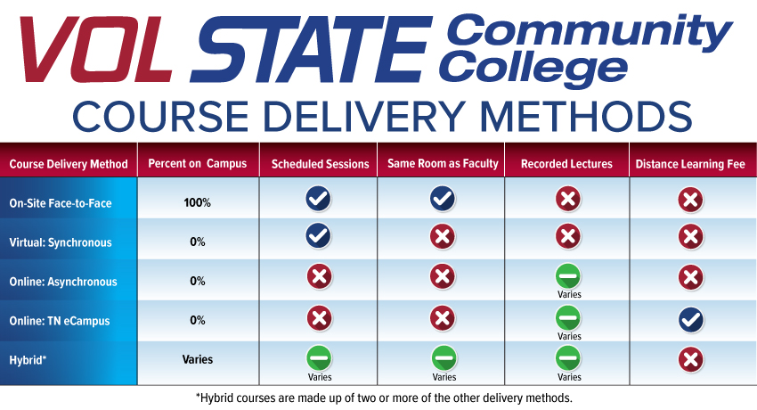
Students may also be confused about whether a virtual class is a required part of your course. Be sure to communicate with them what your course meeting requirements are. Here is one example that may be customized or adapted to your course.
You are enrolled in CHEM 1030 Y51 lecture and CHEM 1030 Y91 lab. In addition to normal course assignment requirements and due dates, there are required online synchronous meetings in this course. Please note the following requirements.
  - CHEM 1030 Y51 meets Monday and Wednesday from 6:00 PM – 7:25 PM via Zoom.
    - The Zoom meeting ID for this class is 123 4567 8910 or
    - Join URL: https://volstate.zoom.us/j/12345678910
  - CHEM 1030 Y91 meets Monday from 7:35 PM – 9:25 PM via Zoom.
    - The Zoom meeting ID for this class is 123 4567 8910 or
    - Join URL: https://volstate.zoom.us/j/12345678910
  - This is a synchronous course, which means you must be present to take ALL exams live on Zoom during the class time; complete in class assignments live during class time; complete any quizzes or other instructional assessment live during class time.
  - You must be present in lab to do the lab experiment at the lab time to receive credit for completing the lab. If you are not there, you receive a zero for that lab.

If I want to hold optional virtual sessions with students, do I have to use Zoom?
The College’s primary instructional video tool is Zoom. It may be assumed that Microsoft Teams would act as a backup to Zoom, but it is not currently recommended. While Microsoft Teams can be used for virtual meetings, it does not have the same meeting capabilities as Zoom does when it comes to classroom usage and the IT department is unable to provide the same level of support for Microsoft Teams as they do for Zoom. The guidance in this document as it relates to FERPA issues and protection of student privacy applies to all forms of audio-visual class delivery tools.

How will my students be notified of virtual Zoom session details?
Faculty are responsible for setting up their virtual class meetings and for providing the meeting link to students.
You are encouraged to share the link to Zoom sessions broadly with students so that they have easy access. You can post it in course announcements, add events with the link to the course calendar, post a page in content, and/or send it via email and eLearn course mail.
Will students know how to use Zoom?
Students may need instructions and support on how to use Zoom initially. Please share this help link with them which shows them exactly how to access and use Zoom: Accessing Zoom.
Additionally, students may need instructions from you on etiquette and expectations during virtual class times. Here are some tips and reminders to share with students, but feel free to adapt.
- Dress like you would for class on campus.
- Login 5 minutes early. Test your speakers and microphone before class starts.
- Be prepared. Have everything ready and easy to reach, such as books, pen, paper, etc.
- No multitasking while on Zoom. No driving, gaming, Netflix, etc.
- Keep your microphone muted until you are ready to speak.
- Turn off your camera if you’re interrupted and or need to take a break.
- Send your instructor a chat message if you step away for a minute.

How can I restrict my classes to only enrolled students?
Steps are listed in this Knowledge Base article about Restricting Zoom Classes to Only Enrolled Students.
You are also required by Zoom to use a meeting passcode or waiting room as an additional security measure. See Securing Zoom Meetings for details.

Should I require students to turn on their video during a Zoom session?
This is your choice as the instructor. Please consider the following potential issues and possible solutions.
- Students might not have a webcam or high-speed internet access.
  - Refer students to IT where they can request to check out a jet pack, webcam, or other basic hardware. Share this link to the Student Technology Checkout Request Form.
- Students might not want to show where they are located. If a student is couch surfing or homeless, and you force them to reveal this to the class, this might negatively impact their motivation and the way the rest of the class perceives them.
  - There are things you can teach your students to help them conceal their location, such as camera angling, placing themselves against a wall, using a sheet to hide parts of the room or use of virtual background.
- Students might be living with minors or others who are not able to provide informed consent to being viewed or recorded by others.
  - Ask students to mute their audio and/or stop video sharing if another person enters the room and to communicate any issues with the instructor.
- Students might have a disability that they do not wish to display. In fact, they might have chosen a distance education class so that they would not be subject to stares and whispers of other students.
  - Direct students with a disability to the Access Center to request accommodation.
- Students might have experienced adverse childhood experiences and being forced to stare at themselves in a camera can be a triggering experience.
  - Teach students how to hide their self-view from the participant list. They can right-click their image or click the ellipsis (3 dots) in the upper part of the image and select Hide Self View as shown below.
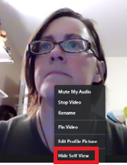
For more on the potential negative impacts of cameras in class, and ideas for alternative ways to engage students, see: Karen Costa, “Cameras Be Damned.”

I don’t record classes when I teach on-campus. Do I need to record Zoom sessions?
As a general rule, no, you don’t need to record Zoom class sessions. Your department or your external accrediting body might have established new requirements during times when classes can’t be offered on-campus. However, there is no College requirement that you record Zoom class sessions.

Are video or audio recordings of lectures protected student records?
If a recording includes only the instructor, it is not a student record and FERPA does not limit its use. If the recording includes students asking questions, making presentations or leading a class, and it is possible to identify the student, then the portions containing recordings of the student do constitute protected educational records. Educational records can only be used as permitted by FERPA or in a manner allowed by a written consent from the student.

What recording settings should I select in my Zoom account to best ensure myself and the students are not recorded in the archive?
Steps are listed in this Knowledge Base article about Restricting the Recording of Self-View and Students in the Classroom.

Can I publicly share a screen capture of a Zoom session or recording that shows one or more identifiable students?
In order to comply with FERPA, you should share a screen capture or recording of a student only with that student’s consent. Likewise, we encourage you to model informed consent with your students by asking them if and when you can record. In short, we discourage you from making or sharing screenshots of students unless you take steps to completely conceal all students’ names and faces. The screen shot below is an example of an instructor who has concealed student faces in the image.
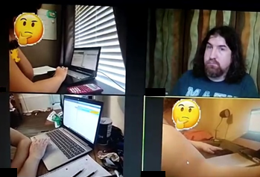

Can students publicly share class recordings or screen captures of a Zoom session or recording that show one or more identifiable students?
No. Students should not record or take pictures without your permission. Instructors should tell students that they should not take screen captures or create recordings of virtual sessions. Tell students they should not share any instructor-created recording links to anyone outside of the class. Students that violate this request may be subject to the student code of conduct for disrupting class, especially if you include this in your syllabus. It is more likely that students will respect your instructions in this regard if you model informed consent before recording them or forcing them to turn on their cameras. The instructor can also disable the ability of a participant to record a zoom meeting as explained in this Zoom support article: local recordings.

Can I show recordings from last year’s class to the current class?
Under FERPA, this situation should be treated as if the recordings were being shown to a third-party audience, which requires FERPA compliance through use of consents from identifiable students or by editing out those students from the video. Before showing class recordings to any other class section (current or future), you will need to edit out any student’s image, name, and voice. Vol State’s Media Services team can assist you with video editing.

If I want to allow access to a video (that shows students participating) to others outside of the class, is this permitted?
Possibly. There are a couple of ways to use recordings that show students participating.
- The instructor may obtain individualized written FERPA consents from the students shown in the recording. This type of consent can be obtained on a case-by-case basis or from all the students at the outset of a class. (See Appendix 1 for an example form.)
- Recordings can be edited to remove portions of the video that show students who have not consented to the use of their voice and/or image. Simply blurring a student’s image and removing their name is not sufficient, as the student may still be identified. Be sure to completely remove or conceal the student’s likeness and name if you choose to edit the recording.

What is the easiest way to comply with FERPA if I am recording virtual class sessions with students and I wish to share the recording with a future class?
Overall, plan your Zoom session as carefully as you plan your face-to-face classes.
Also, refer to best practices above regarding the configuration of recording settings within Zoom.
Don’t refer to students by name (de-identifying the students removes the need for a specific consent from each student depicted). If a student happens to appear on camera or their voices are recorded, their identity can either be edited out or written consent can be obtained.

What if my course activities require student demonstrations or recordings?
The course outline of record for some courses requires students to perform certain activities or demonstrate skills in order to meet course objectives. An example might be COMM 2045 Public Speaking. In these cases, instructors should strive to disclose to students what will be required before the start of class. This might occur via the instructor orientation letter, printed comments in the schedule of classes, and/or a department or instructor website. The instructor should also add a statement to the course syllabus outlining requirements and how to request alternative arrangements if needed.
Videos of students giving presentations and student-generated video projects are covered by FERPA and copyright (students own the copyright of their work, just as any other author/creator). Therefore, written permission to use these digital works must be obtained from the student.

What happens once I record a session?
As the meeting host, you decide when to record a session. All Vol State user Zoom sessions are recorded to the Zoom Cloud by default and backed up to your Kaltura MyMedia account. Zoom Cloud recordings in Zoom will be deleted automatically after they have been stored for 180 days. Recordings in MyMedia will be kept indefinitely. You decide whether to share the recording link or not.

How do I obtain written consent from a student?
To obtain written FERPA consent from students for instructional video recordings, please see Appendix 1 for example wording. You may collect the consent forms electronically via email or using eLearn. Here are some options:
- Send a copy of the consent form to all students via Vol State email and require them to reply to you with their written consent in the same manner. Vol State email serves in place of a “written” signature. (This option is recommended by the VSCC IT department.)
- Post the consent form as an eLearn quiz question and require students to complete the “quiz” by selecting either “I consent” or “I do not consent” as the answer possibilities.
- Post the consent form as a Word document and require students to type their name with a modification “by typing my name and submitting this file to the dropbox, I consent.” Instruct students to submit the e-signed document to you via an eLearn dropbox folder created for this purpose.
Retain the consent form so long as you intend to use the recording.
In addition to the FERPA consent form, but never as a substitution, it is also a best practice within Zoom to obtain participant consent before recording.
- Go to volstate.zoom.us and click Login to Create/Edit Account in order to create your Zoom account or edit your Zoom account settings.
- In the left column, select Settings.
- Select the Recording tab and choose the following settings:
- Toggle Recording disclaimer to Enable the setting
- Enable the checkbox on the setting Ask participants for consent when a recording starts
- Toggle Multiple audio notifications of recorded meeting to Enable the setting

Whenever you record a meeting, participants will first need to interact with the recording consent disclaimer by clicking Continue.
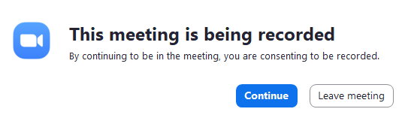

How do I accommodate students with disabilities who need captions?
As suggested above, plan your class session so that you are recording only the parts of class that show you or your instructional material.
Also, note that not all virtual class sessions, e.g., via Zoom, need to be captioned. Virtual class sessions need to be captioned when a student is present who has an academic accommodation plan developed with the Access Center that identifies captions as an accommodation. If a student has an approved accommodation for captions through the Access Center, the details will be provided to you via the Access Center. For questions about how to support students with disabilities at Volunteer State Community College, please contact the Access Center.
Even if there’s no student with a disability, all pre-recorded videos do need to be captioned, in order to make them accessible to all students (a.k.a. Section 508 compliance). Auto-generated captions will have errors. As the instructor, you are responsible for reviewing and correcting those captions. Captions must be at least 99% accurate and include punctation.

Where can I find additional answers about Zoom?
Vol State has provided supplemental information about Zoom in the Knowledge Base. If you cannot find the answer there, you can always submit a ticket in the IT ticket system or contact the Vol State IT Help Desk at 615-230-3302.

Appendix 1

Permission to record – Online course recordings
Student First and Last Name:
Student V#:
Course:
The Family Educational Rights and Privacy Act (FERPA) regulates the disclosure of educational information. FERPA states “when a student becomes an eligible student (18 years of age or is attending an institution of postsecondary education), the rights accorded to, and consent required of, parents under this part transfer from the parents to the student.
I understand that my instructor will record our virtual/synchronous online sessions for myself and other students in course to view at a later time. I understand the instructor will notify the students when a session is being recorded. I understand the recording of the video will not be used for other purposes outside of this course.
BY SIGNING THIS FORM, I waive my FERPA rights for the instructor to use my voice, name, questions I ask during the recording, my video, etc., that is recorded during the course session, for use within the classroom.
Student Signature________________________________ Date ________________________
===============================================================
To rescind the Release of Information, contact your instructor.

NOTES:

